**Drowsiness Alert**

Link of my app code: <https://github.com/ritvikraj14/DrowsinessAlert>

**The drowsiness detector algorithm**

The general flow of our drowsiness detection algorithm is fairly straightforward:

First, we’ll setup a camera (webcam) that monitors a stream for faces:

If a face is found, we apply facial landmark detection and extract the eye regions: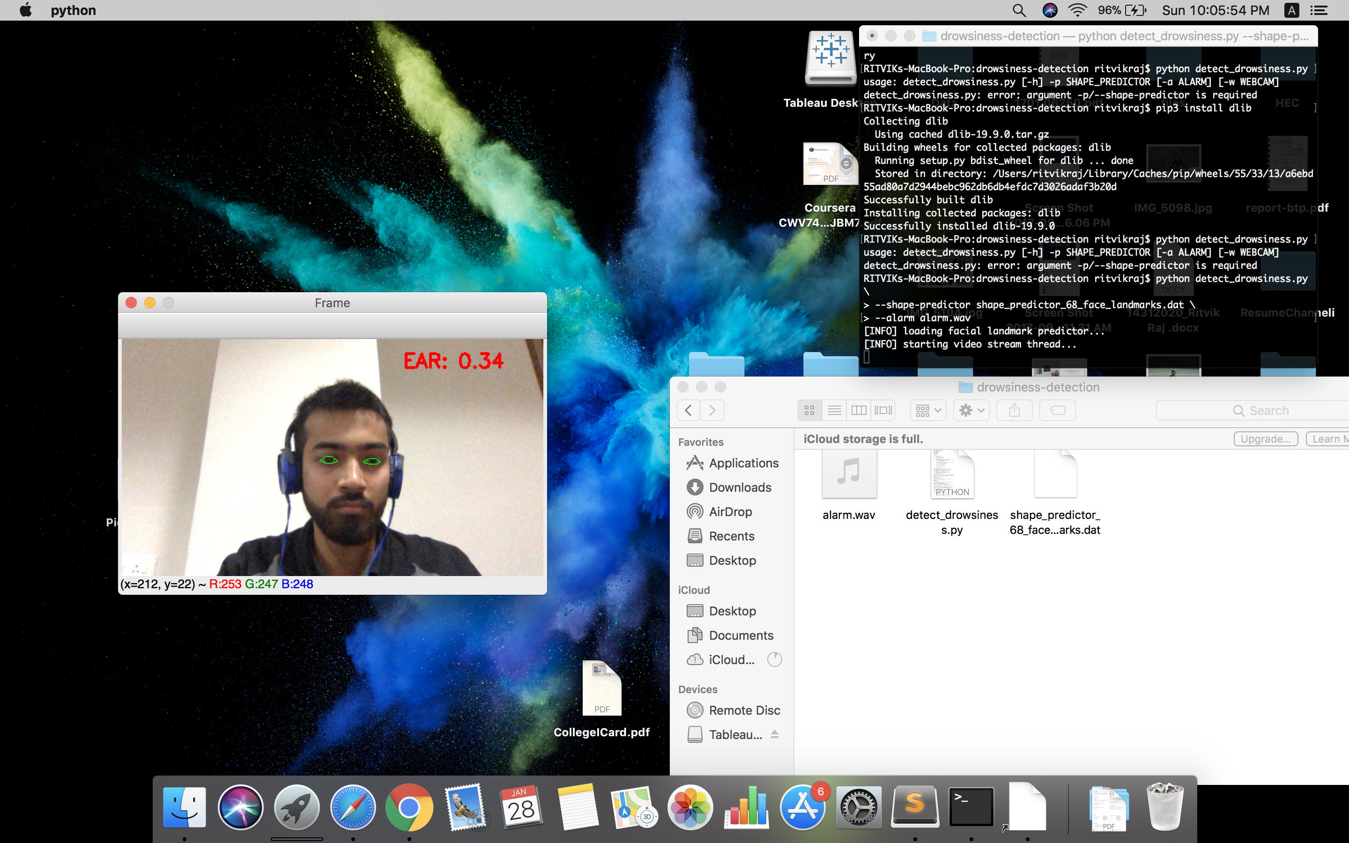

Now that we have the eye regions, we can compute the eye aspect ratio to determine if the eyes are closed:

If the eye aspect ratio indicates that the eyes have been closed for a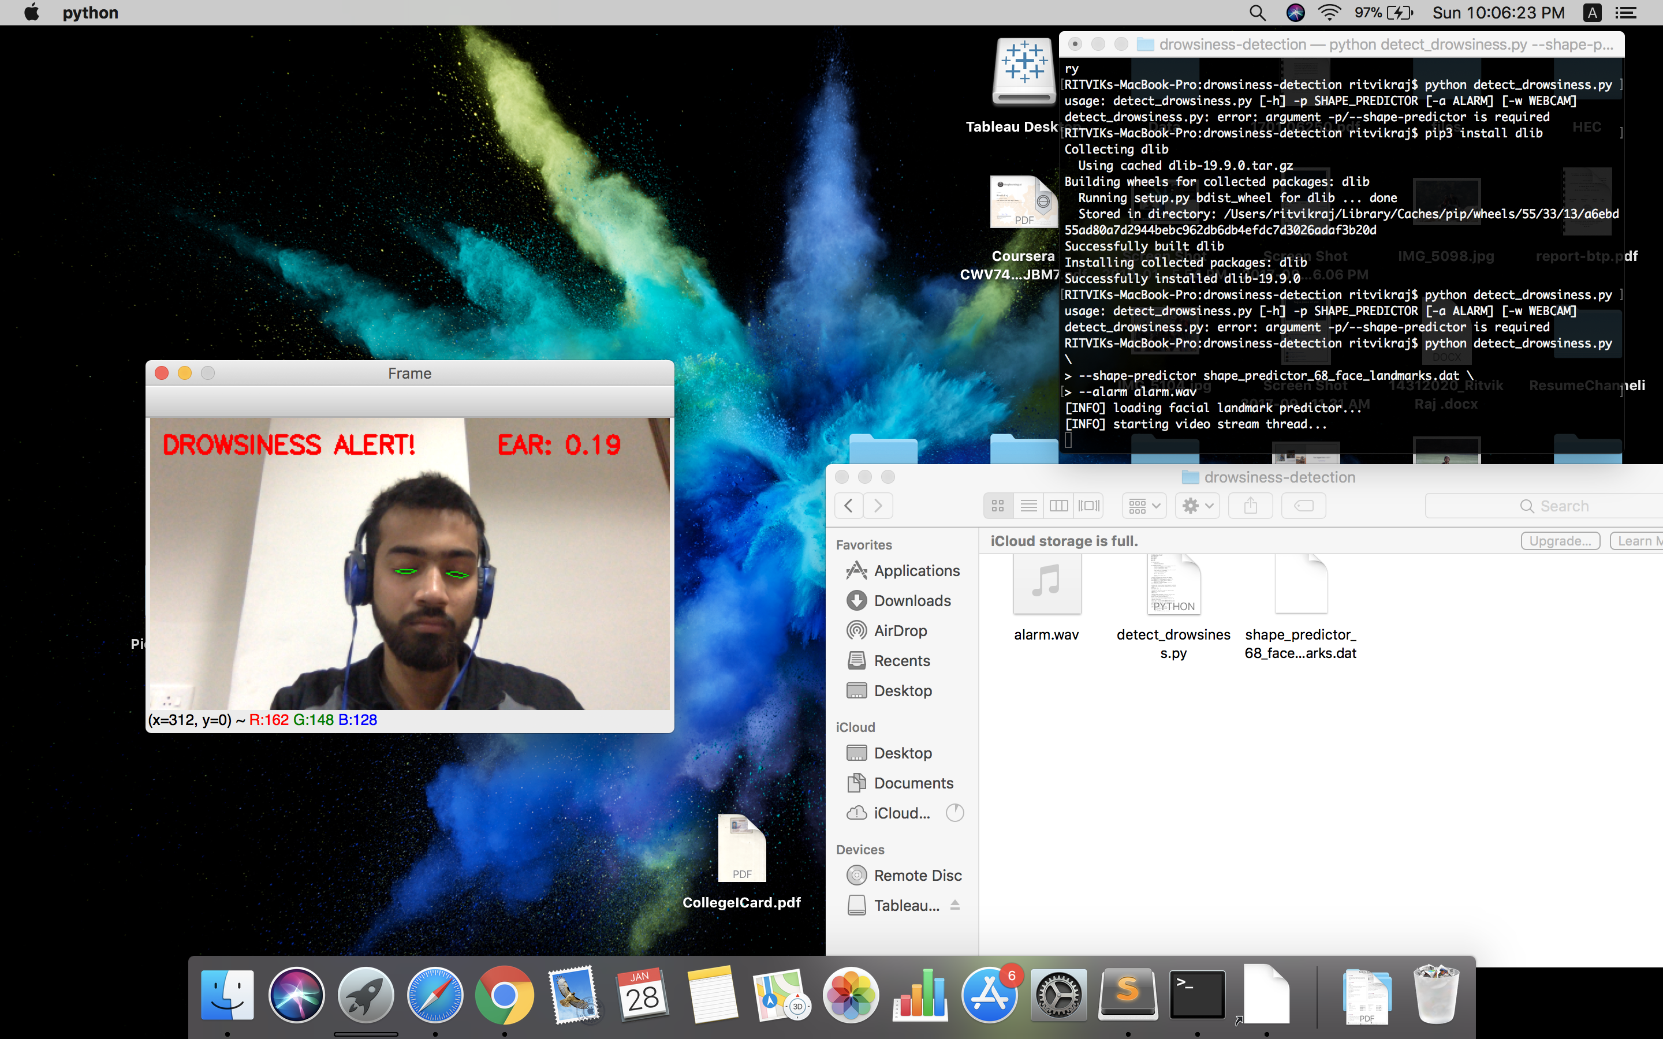 sufficiently long enough amount of time, we’ll sound an alarm to wake up the driver.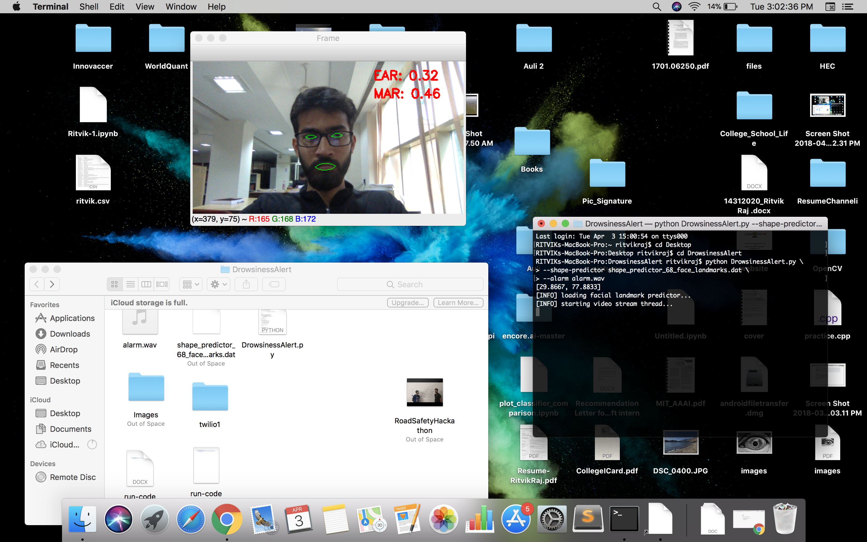

The same procedure is repeated for yawing.

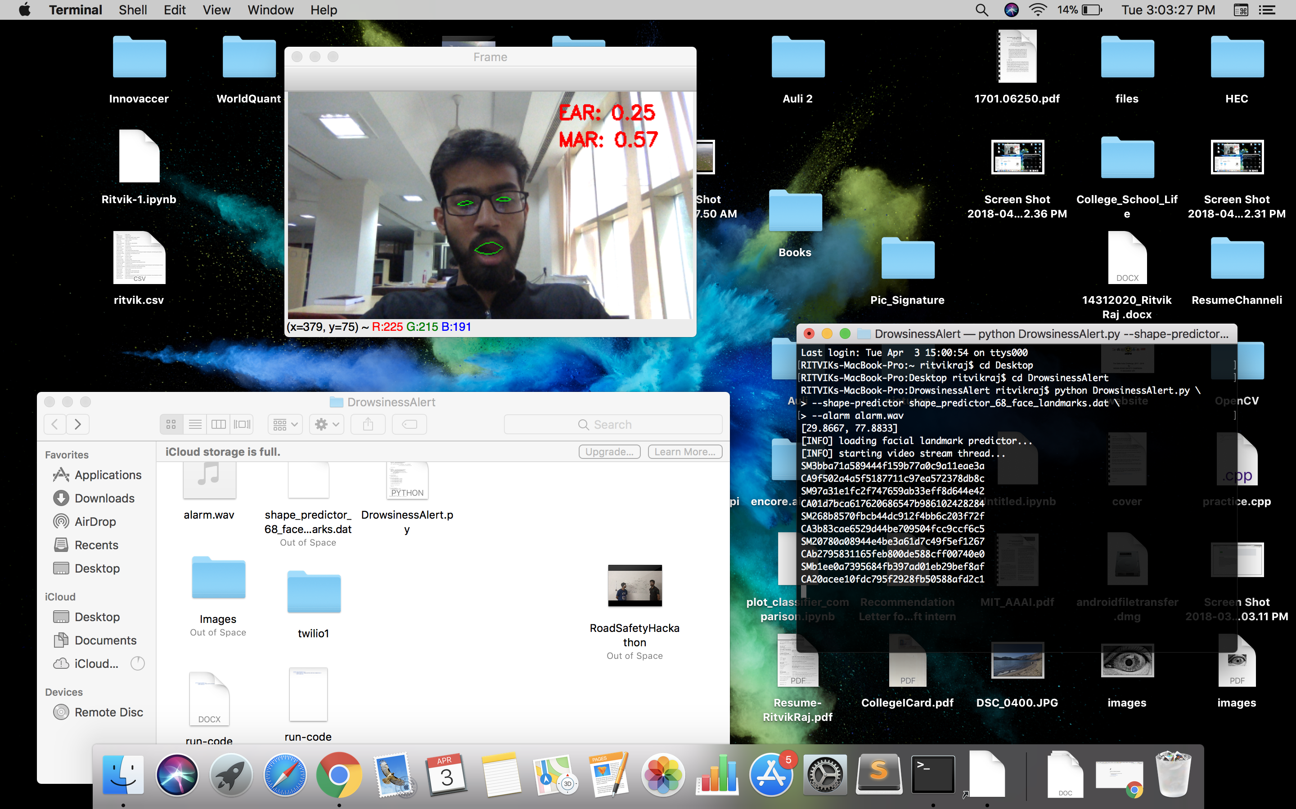

We implemented the drowsiness detection algorithm detailed above using OpenCV, dlib, and Python (explanation in comments of code)

 As the results show, our drowsiness detector is able to detect when I’m at risk of dozing off and then plays a loud alarm to grab my attention.

The drowsiness detector is even able to work in a variety of conditions, including direct sunlight when driving on the road and low/artificial lighting while in the concrete parking garage.

Our drowsiness detector hinged on two important computer vision techniques:

Facial landmark detection

Eye aspect ratio

Facial landmark detection is the process of localising key facial structures on a face, including the eyes, eyebrows, nose, mouth, and jawline.

Specifically, in the context of drowsiness detection, we only needed the eye regions and the mouth region.

Once we have our eye regions, we can apply the eye aspect ratio to determine if the eyes are closed. If the eyes have been closed for a sufficiently long enough period of time, we can assume the user is at risk of falling asleep and sound an alarm to grab their attention

Now suppose if somehow accident occurs,

In that case, eyes will be closed for more than some threshold number of frames (user defined).

For tha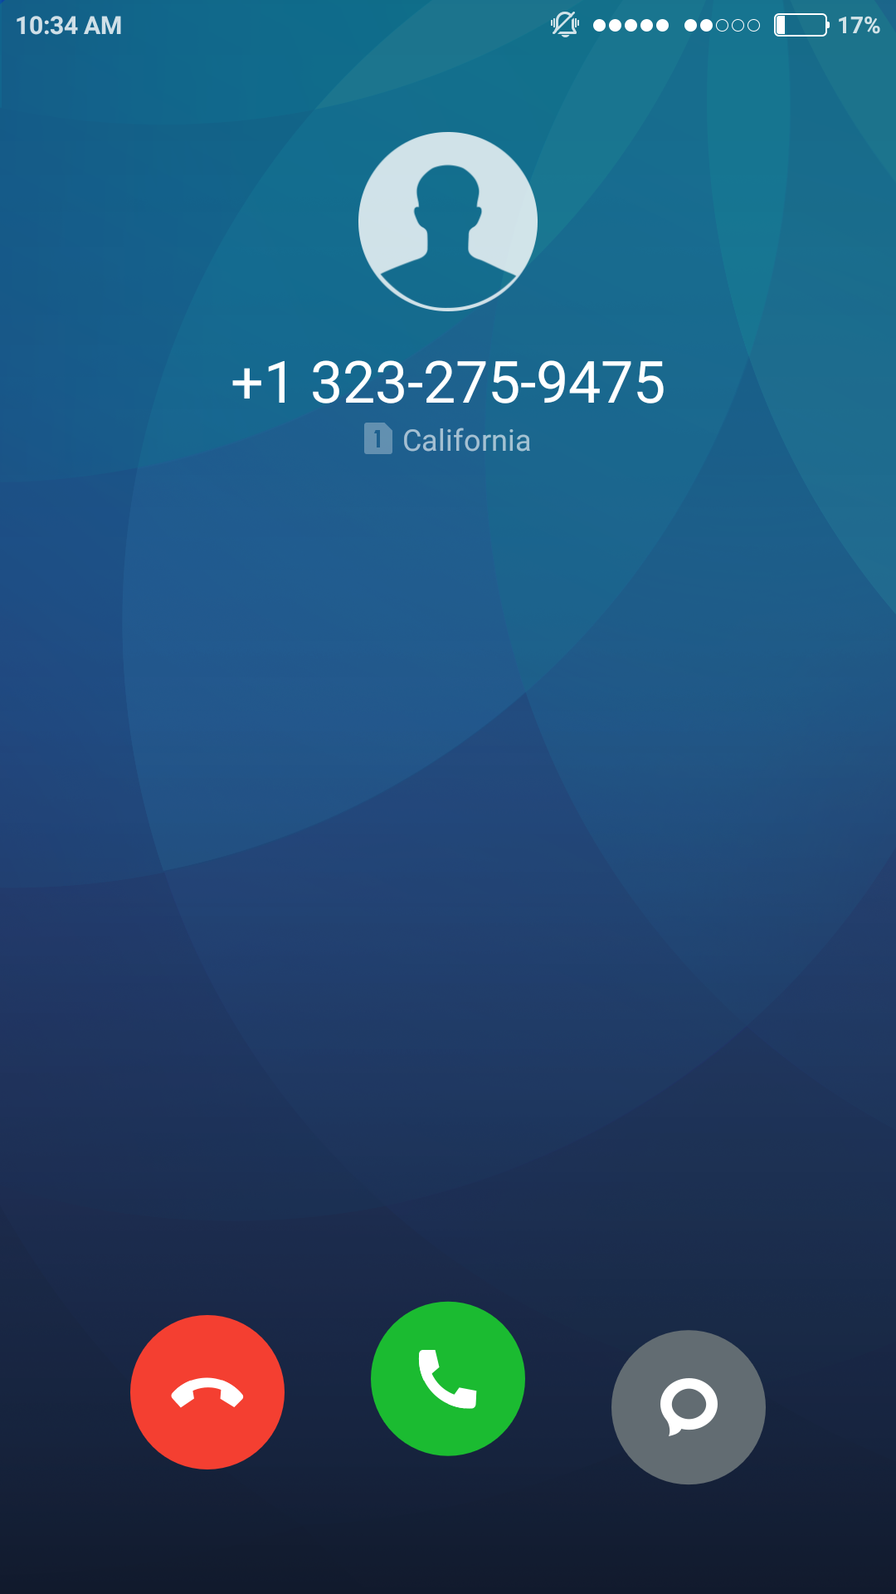t, we have implemented that an automated call, a message with a GPS location will be sent to some important contact or to some nearest hospital.

Steps to run the code:

1. Use the link below to download the shape predictor 68 landmarks:

<https://drive.google.com/drive/u/1/folders/1yio8CFZGv-g6TzdReo8NzvQa43DIPqWK>

2. 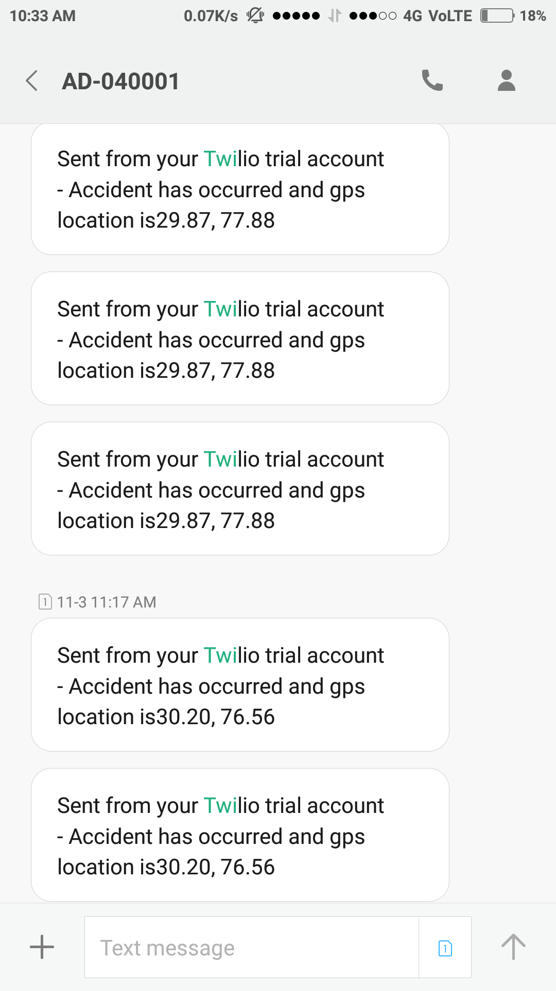Make your Twilio account and replace the details in credentials.py with your own account details.

3. Keep Shape predictor (download from above link), DrowsinessAlert.py, twilio1 in one folder and run the Drowsines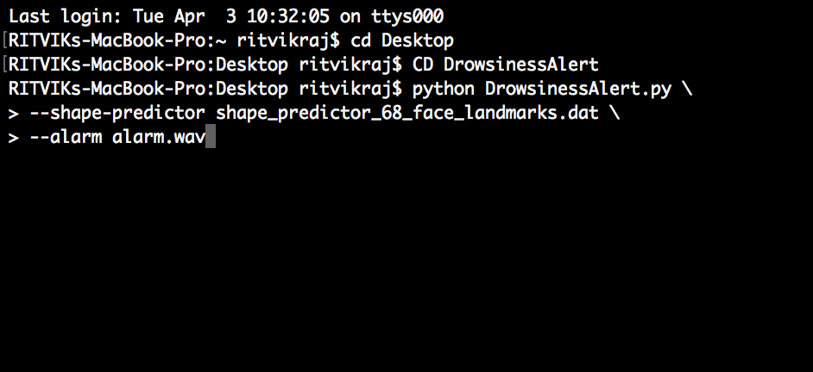sAlert.py from the terminal using the instruction given in run-code.docx

**How closing of eyes and yawn is defined:** 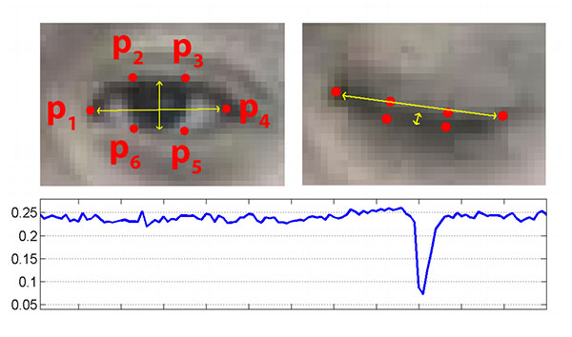

**Facial fe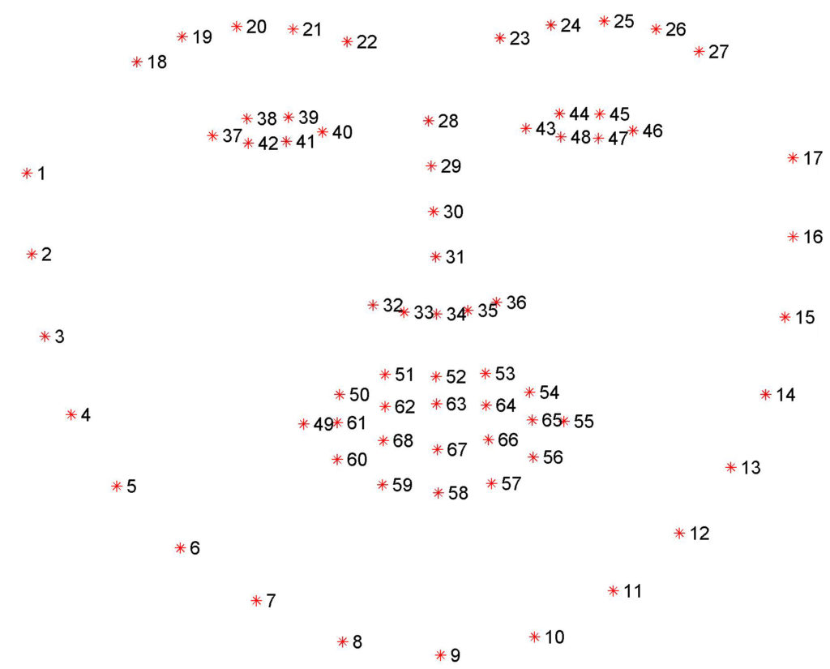atures:**